Right Pentagonal Pyramid
# Source: AI Source: Provided by: [Data Path: Persons Table -> ID Column: 1, Name_En Column: Motasem Essam] -> From: [ChatGPT] on [7/25/2026]
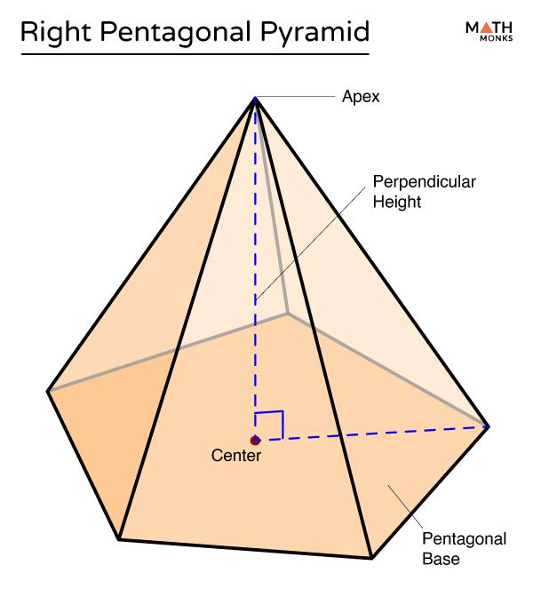
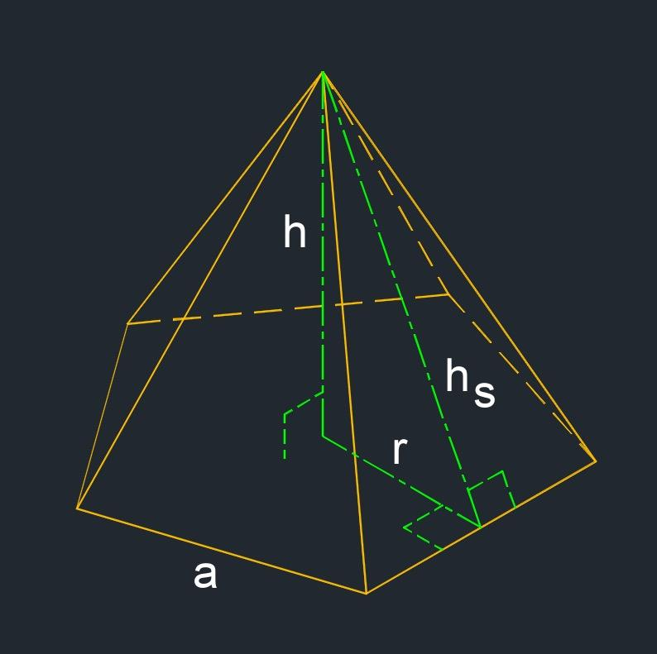
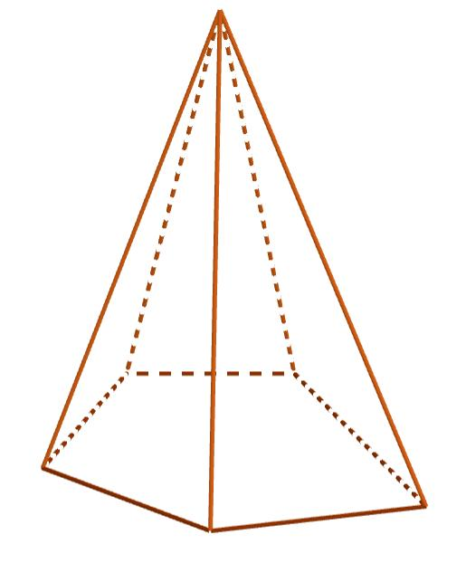

Definition
# Source: AI Source: Provided by: [Data Path: Persons Table -> ID Column: 1, Name_En Column: Motasem Essam] -> From: [ChatGPT] on [7/25/2026]
A right pentagonal pyramid is a three-dimensional geometric solid with a pentagonal base and five triangular lateral faces that meet at a single point called the apex. It is right when the perpendicular from the apex to the plane of the base meets the base at its designated center.
The base can be a regular or irregular pentagon, although the term right pentagonal pyramid is most straightforward when the base center is clearly defined. A right pentagonal pyramid with a regular pentagonal base is also a regular pentagonal pyramid under the usual convention.

Simple Definition
# Source: AI Source: Provided by: [Data Path: Persons Table -> ID Column: 1, Name_En Column: Motasem Essam] -> From: [ChatGPT] on [7/25/2026]
A right pentagonal pyramid is a pyramid with a five-sided base whose apex is directly above the center of the base, so its height is perpendicular to the base.

Key Characteristics
# Source: AI Source: Provided by: [Data Path: Persons Table -> ID Column: 1, Name_En Column: Motasem Essam] -> From: [ChatGPT] on [7/25/2026]
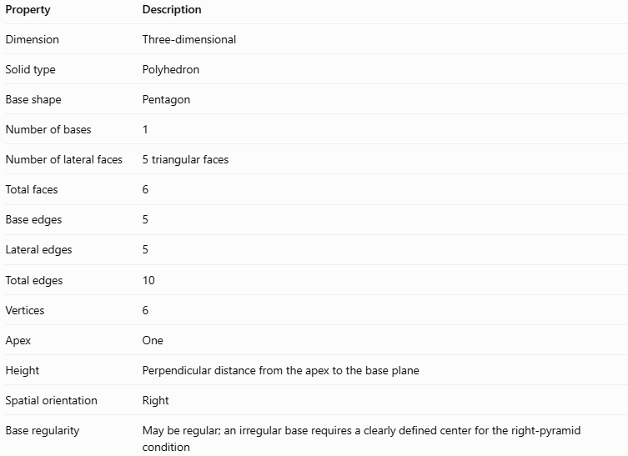
Property | Description
Dimension | Three-dimensional
Solid type | Polyhedron
Base shape | Pentagon
Number of bases | 1
Number of lateral faces | 5 triangular faces
Total faces | 6
Base edges | 5
Lateral edges | 5
Total edges | 10
Vertices | 6
Apex | One
Height | Perpendicular distance from the apex to the base plane
Spatial orientation | Right
Base regularity | May be regular; an irregular base requires a clearly defined center for the right-pyramid condition

Geometric Representation
# Source: AI Source: Provided by: [Data Path: Persons Table -> ID Column: 1, Name_En Column: Motasem Essam] -> From: [ChatGPT] on [7/25/2026]
The main components are:
- Pentagonal base: The five-sided polygon at the bottom.
- Apex: The point where all five lateral triangular faces meet.
- Base edges: The five edges around the pentagonal base.
- Lateral edges: The five segments connecting the apex to the base vertices.
- Lateral faces: The five triangular faces joining the base edges to the apex.
- Height ($h$): The perpendicular segment from the apex to the base plane.
- Slant height ($l$): For a regular right pentagonal pyramid, the perpendicular distance along a lateral face from the apex to the midpoint of a base edge.
For a regular right pentagonal pyramid, the apex lies directly above the center of the regular pentagon. Its five lateral faces are congruent isosceles triangles.

Mathematical Representations and Formulas
# Source: AI Source: Provided by: [Data Path: Persons Table -> ID Column: 1, Name_En Column: Motasem Essam] -> From: [ChatGPT] on [7/25/2026]
For a regular right pentagonal pyramid, let:
- $a$ = side length of the pentagonal base
- $h$ = perpendicular height of the pyramid
- $l$ = slant height of a lateral face
- $R$ = circumradius of the base
- $r$ = apothem of the base
- $p$ = perimeter of the base
- $B$ = area of the base

A. Base perimeter
# Source: AI Source: Provided by: [Data Path: Persons Table -> ID Column: 1, Name_En Column: Motasem Essam] -> From: [ChatGPT] on [7/25/2026]
A regular pentagon has five equal sides.
$$p=5a$$

B. Base apothem
# Source: AI Source: Provided by: [Data Path: Persons Table -> ID Column: 1, Name_En Column: Motasem Essam] -> From: [ChatGPT] on [7/25/2026]
$$r=\frac{a}{2{\tan{36}}^{∘}}$$

C. Base area
# Source: AI Source: Provided by: [Data Path: Persons Table -> ID Column: 1, Name_En Column: Motasem Essam] -> From: [ChatGPT] on [7/25/2026]
$$B=\frac{1}{2}pr$$
Equivalently,
$$B=\frac{5a^{2}}{4{\tan{36}}^{∘}}$$

D. Slant height
# Source: AI Source: Provided by: [Data Path: Persons Table -> ID Column: 1, Name_En Column: Motasem Essam] -> From: [ChatGPT] on [7/25/2026]
The slant height, perpendicular to a base edge within a lateral face, is:
$$l=\sqrt{h^{2}+r^{2}}$$
This follows from the Pythagorean theorem.

E. Lateral surface area
# Source: AI Source: Provided by: [Data Path: Persons Table -> ID Column: 1, Name_En Column: Motasem Essam] -> From: [ChatGPT] on [7/25/2026]
The pyramid has five congruent triangular lateral faces.
$$A_{L}=\frac{1}{2}pl$$
Or, using the side length:
$$A_{L}=\frac{5}{2}al$$

F. Total surface area
# Source: AI Source: Provided by: [Data Path: Persons Table -> ID Column: 1, Name_En Column: Motasem Essam] -> From: [ChatGPT] on [7/25/2026]
$$A_{T}=B+A_{L}$$

G. Volume
# Source: AI Source: Provided by: [Data Path: Persons Table -> ID Column: 1, Name_En Column: Motasem Essam] -> From: [ChatGPT] on [7/25/2026]
$$V=\frac{1}{3}Bh$$

H. Lateral edge length
# Source: AI Source: Provided by: [Data Path: Persons Table -> ID Column: 1, Name_En Column: Motasem Essam] -> From: [ChatGPT] on [7/25/2026]
The lateral edge joins the apex to a vertex of the base. Its length is:
$$e=\sqrt{h^{2}+R^{2}}$$
where the circumradius of the regular pentagon is:
$$R=\frac{a}{2{\sin{36}}^{∘}}$$
Important distinction: The slant height $l$ is not the same as the lateral edge length $e$. The slant height meets the midpoint of a base edge, while the lateral edge meets a base vertex.

Worked Examples
# Source: AI Source: Provided by: [Data Path: Persons Table -> ID Column: 1, Name_En Column: Motasem Essam] -> From: [ChatGPT] on [7/25/2026]
Example 1: Counting faces, edges, and vertices
A right pentagonal pyramid has a pentagonal base.
- Faces: $5+1=6$
- Edges: $2\left(5\right)=10$
- Vertices: $5+1=6$
Check Euler’s formula:
$$V_{e}-E+F=6-10+6=2$$
Here, $V_{e}$ represents the number of vertices, not volume.
Example 2: Calculating the volume
Suppose a regular right pentagonal pyramid has a base area of $60{\text{ cm}}^{2}$ and a perpendicular height of $9\text{ cm}$.
Using the volume formula:
$$V=\frac{1}{3}Bh$$
Substitute the values:
$$V=\frac{1}{3}\left(60\right)\left(9\right)$$
$$\boxed{V=180{\text{ cm}}^{3}}$$
Example 3: Calculating surface areas
Suppose a regular right pentagonal pyramid has a base side length of $6\text{ cm}$ and a perpendicular height of $8\text{ cm}$.
Step 1 — Calculate the base perimeter
$$p=5\left(6\right)=30\text{ cm}$$
Step 2 — Calculate the base apothem
$$r=\frac{6}{2{\tan{36}}^{∘}}≈4.129\text{ cm}$$
Step 3 — Calculate the base area
$$B=\frac{1}{2}\left(30\right)\left(4.129\right)$$
$$B≈61.94{\text{ cm}}^{2}$$
Step 4 — Calculate the slant height
$$l=\sqrt{8^{2}+{4.129}^{2}}$$
$$l≈9.003\text{ cm}$$
Step 5 — Calculate the lateral surface area
$$A_{L}=\frac{1}{2}\left(30\right)\left(9.003\right)$$
$$A_{L}≈135.04{\text{ cm}}^{2}$$
Step 6 — Calculate the total surface area
$$A_{T}=61.94+135.04$$
$$\boxed{A_{T}≈196.98{\text{ cm}}^{2}}$$

Comparison with Related Concepts
# Source: AI Source: Provided by: [Data Path: Persons Table -> ID Column: 1, Name_En Column: Motasem Essam] -> From: [ChatGPT] on [7/25/2026]
Right Pentagonal Pyramid
Its apex lies above the designated center of its pentagonal base, and its height is perpendicular to the base plane.
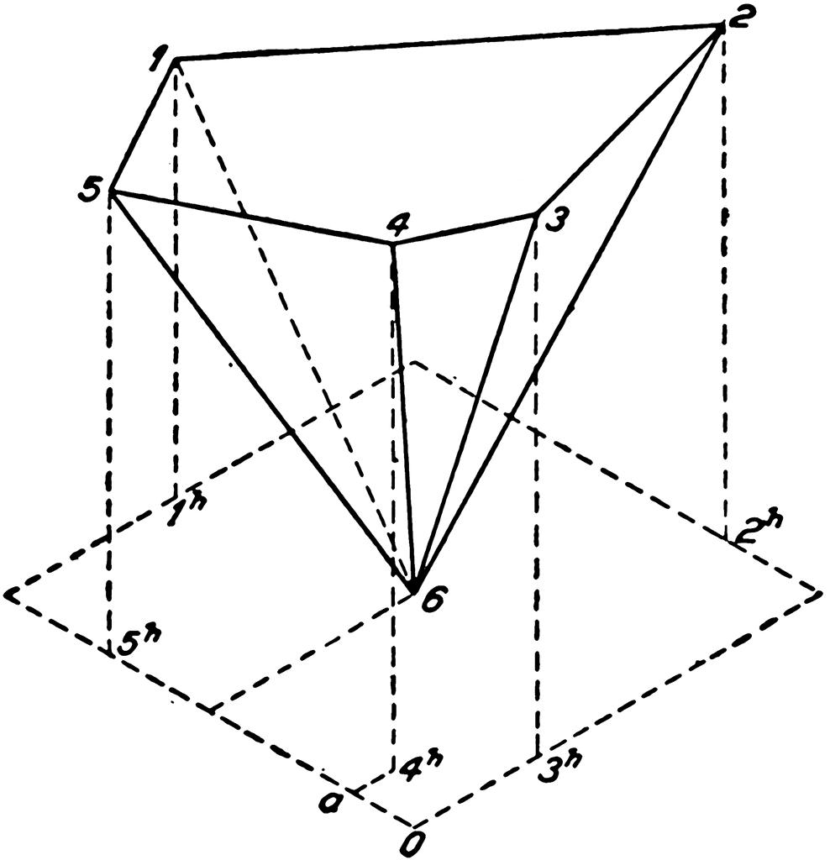
Oblique Pentagonal Pyramid
Its apex is not positioned directly above the designated base center. Its lateral edges are generally not all equal.
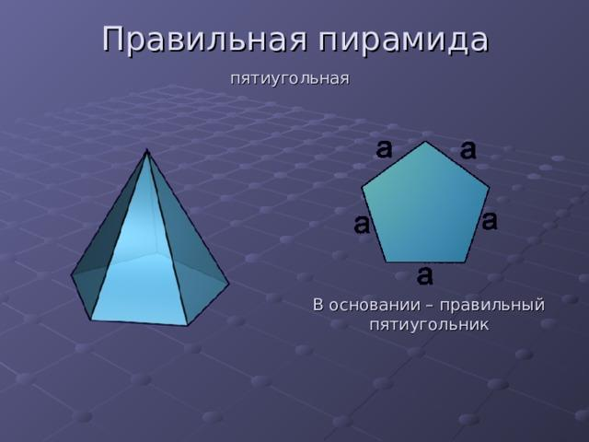
Regular Pentagonal Pyramid
Its base is a regular pentagon and its apex lies above the base center. The five lateral faces are congruent isosceles triangles.
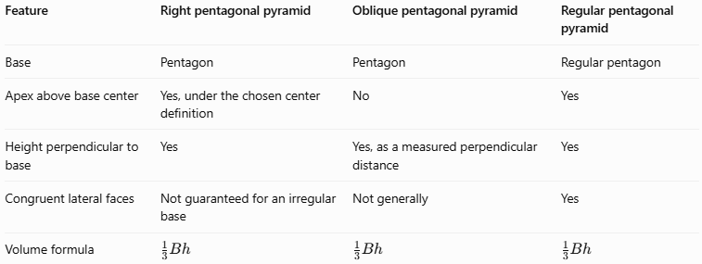
Feature | Right pentagonal pyramid | Oblique pentagonal pyramid | Regular pentagonal pyramid
Base | Pentagon | Pentagon | Regular pentagon
Apex above base center | Yes, under the chosen center definition | No | Yes
Height perpendicular to base | Yes | Yes, as a measured perpendicular distance | Yes
Congruent lateral faces | Not guaranteed for an irregular base | Not generally | Yes
Volume formula | $$\frac{1}{3}Bh$$ | $$\frac{1}{3}Bh$$ | $$\frac{1}{3}Bh$$
A regular pentagonal pyramid is a special case of a right pentagonal pyramid. A right pyramid with an irregular pentagonal base is not necessarily a regular pyramid.

Applications
# Source: AI Source: Provided by: [Data Path: Persons Table -> ID Column: 1, Name_En Column: Motasem Essam] -> From: [ChatGPT] on [7/25/2026]
- Architecture: Decorative pyramid-shaped roofs and ornamental structures.
- Packaging: Five-sided pyramid-shaped gift boxes and display containers.
- Mathematical modeling: Studying height, slant height, surface area, and volume.
- Computer graphics: Constructing and rendering polygonal 3D models.
- Engineering and design: Estimating material requirements for pyramid-shaped components.

Key Points
# Source: AI Source: Provided by: [Data Path: Persons Table -> ID Column: 1, Name_En Column: Motasem Essam] -> From: [ChatGPT] on [7/25/2026]
- A right pentagonal pyramid has 6 faces, 10 edges, and 6 vertices.
- It has one pentagonal base and five triangular lateral faces.
- Its height is perpendicular to the base plane.
- The volume is one-third of the base area multiplied by the perpendicular height.
- The regular right version has five congruent lateral faces.
- The lateral edge and slant height are different measurements.
- For an irregular pentagonal base, use the actual base area and calculate lateral face areas individually when they are not congruent.

Conclusion
# Source: AI Source: Provided by: [Data Path: Persons Table -> ID Column: 1, Name_En Column: Motasem Essam] -> From: [ChatGPT] on [7/25/2026]
A right pentagonal pyramid is a polyhedron characterized by a five-sided base and an apex positioned above the designated center of that base. Its geometry combines a pentagonal base, five triangular lateral faces, and a perpendicular height. Understanding the difference between height, slant height, and lateral edge length is essential for solving its surface-area and volume problems.

